
Portfolio
Project 1
Version #5.0

All work Copyright © 2014 by Jordan Cooper.
All rights reserved.

Jordan Cooper

March-3-14

Table of Contents
Description Page 3.
Nav Bar section Page 3.
Color Selection Page 3.
Typography Page 4.
Wireframes Page 5.
Branding Selection Page 7.

Site Description

This site was created as a mobile portfolio for my work. The home page provides a brief description of my skills and goals, as well as a preview of my projects. The about me page provides a description of my programming knowledge, and the projects page provides three of my recent program and links the user to github or the application itself. All pages are built using jquery mobile and built for the web, when the user goes to desktop version of this website on a mobile phone then they are redirected to the mobile site.

Navigation Bar


The navigation bar uses jquery mobile, when each page is selected through the navigation bar the selefcted page is highlighted in black. Each section of the navigation bar has its own unique icon that provides a visual indication about what each page will be about. The back button, part of the navigation bar, has been placed in the header(top left button) so the user may travel throughout the site and then go back to previous pages with ease.

Color Schemes

For this project I chose to keep my colors simple, using a light grey for the background (#cccccc) another grey, closer to white for the active link (#606060), the text is pure black on the page and in the nav bar it is white. The nav bar also has a light grey on the hover event. I kept the color scheme quite similar to the original web page to give the user a similar feeling when accessing the website from different platforms.

Background | #cccccc
Active link | 606060
Text | #000000
Nav bar text | #ffffff
Nav bar hover | #eeeeee
Button color | #808080
Button hover | #ffffff

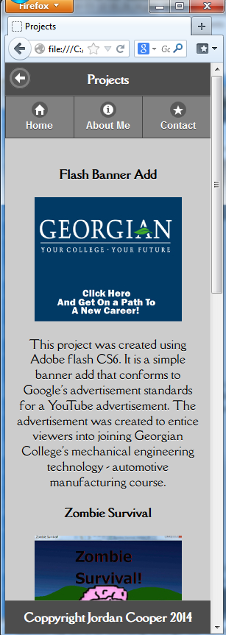
Typography Selections
Area | Font Size | Color | Font
Header  Represented by: “Projects” | 24pt  (H1 tag) | White | Della Respira  (Google Font)
Page Header  Represented by: “Zombie Survival” | 12pt  (H4 tag) | Black | Della Respira  (Google Font)
Page Text  Represented by:  “This project was created using Adobe flash CS6…” | 12pt  (P Tag) | Black | Della Respira  (Google Font)
Footer  Represented by: “Copyright Jordan Cooper 2014” | 12pt  (H4 tag) | White | Della Respira  (Google Font)

Wireframes

Home Page

Title text
logo

Navigation Bar

slider
Navigation For Slider

Tagline

Projects
Services

Desktop Mode

Footer

Back Button
About Me

Title text

Navigation Bar

Photo

Section Header

Section Text

Footer

Back Button
Contact Me

Title text

Navigation Bar

Contact Info
Buttons that auto dial/fill in email info

Email

Telephone

Linked In Image Button

IN

Footer

Back Button
Projects

Title text

Navigation Bar

Image Button of project

Image

Description

Footer

Back Button
Services

Title text

Navigation Bar

Service Title
Image

Description of Service offered

Footer

Branding Section

Logo
Colour: black

Screenshots
Home | About Me | Contact Me
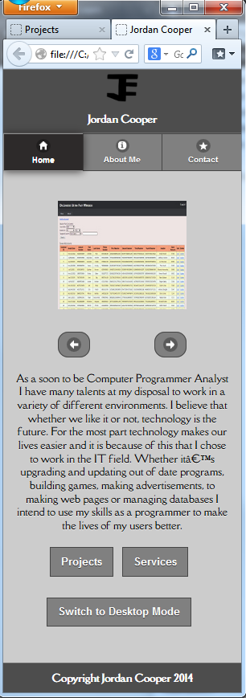 | 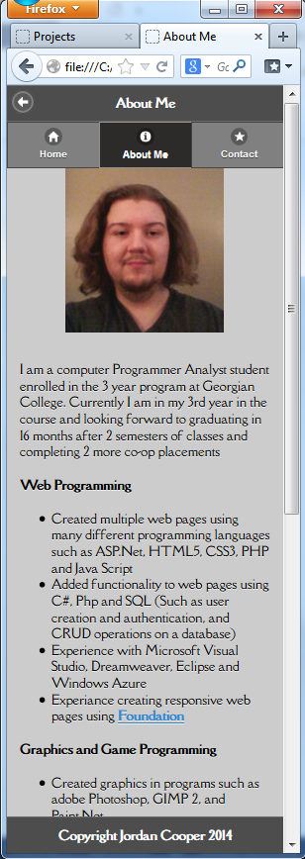 | 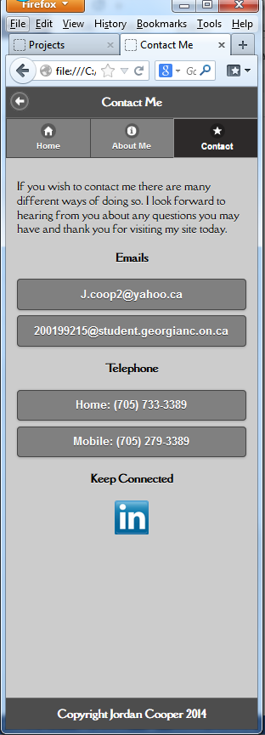
Projects | Services
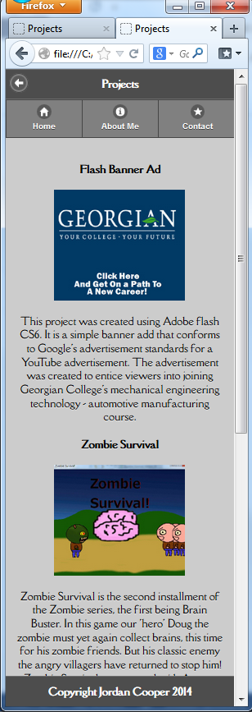 | 